ERENKOY KINDERGARTEN

2025/Konya/TÜRKİYE

Our school is located in Selçuklu district of Konya province; It is the largest pre-school education institution in the 4th education region with 12 branches and 5 club classes, covering pre-school age children from 36 months to 72 months, serving with 280 students, 22 educators and 7 support staff.

Our school has been mobilised to Italy with Erasmus+ adult education with the number 2022-1-TR01-KA121-ADU-0000064654. In addition, in 2023, Konya Provincial Directorate of National Education was included in the accreditation with the K122 project. Our school also successfully carries out e-Twinning projects. It has undertaken the partnership and founder of European Union Projects. It has managed to be among the top 30 projects in Europe with its Zero Waste project. We have over ten National and 8 European Quality labels in e -Twinning studies carried out in our school.

In addition, coding training was given to 200 children from 5 different schools by receiving grant support in the Selçuklu Municipality innovative project, and disadvantaged children were prioritised in this training.In our school, within the scope of MEB pre-school education curriculum applications, social emotional area, motor development, language development, self-care skills, cognitive development areas and preparation for 1st grade are taught. Different teaching methods and techniques are used for the achievements of these education areas. We apply an integrated learning model to our students, whom we support with student-centred education, learning by doing, learning by living and project-based education method. Many excursions, sports-game activities and social activities are carried out. Mathematics is taught by having fun with chess tournament and narrated mathematics 'PLAYMATH' education in Singapore education system.

In addition to our curriculum lessons, piano, English, coding, drama, children's literature, chess and STEM lessons are given to our 120 students who want club lessons after the lessons with 5 branches. Life Skills, mind intelligence games, music education, art design workshops and applied workshop training are provided.

Our club classes offer opportunities for our children to think from different perspectives and to express their feelings through theatre, drama and music education.

In the garden of our school, there are 250 square metres of grass area, children's playground, playgrounds where they can do physical activities and climbing stairs. The semi-structured playground has a glass ceiling and a spacious high ceiling. There are soil areas in our school garden for ecological studies.

REGIO EMILIA APPROACH APPLICATIONS FOR OUR SCHOOL

Learning is a process that begins at birth and continues throughout our lives. But education helps to define our choices, which are the foundation on which life is built. In particular, the quality of education needs to be improved and programmed in the age of development.

Family, educators and housing (organised environment) are important factors in the social and cognitive development of the child. Gaps, flaws and oppressive approaches in the field of education have led to the formulation of new visions of child development by many pedagogues, philosophers and educators. These perspectives have led to the establishment of educational structures that recognise children as special individuals and address both their psychological and spatial needs.

In modernising societies, the duration of education in the family is gradually shortening and it is becoming a phenomenon that is mainly transferred to educational institutions. For this reason, school is one of the most important factors in the development of the child after the family.

However, in the literature reviews conducted in Turkey, the number of in-depth studies on the effect of the spatial quality of the educational structure on children's school performance and whether they are adequate or not depends on the social, psychological and biological conditions of the school is not sufficient.

Reggio Emilia has an educational approach and child-centred education methods that see the environment as an educational tool and an effective factor in learning real life. The emergence of the Reggio Emilia approach covers approximately the period after the Second World War. The adventure of the emergence of this approach is as follows: After the Second World War, families in the village of Villa Serra in the town of Reggio Emilia wanted to build a school for the future of their children. The families built a school with the money they earned from the sale of tanks, lorries and horses. With the help of Malaguzzi and his family, Reggio Emilia's first municipal school was opened.

In our country, Regio Emilia practices have recently started to be integrated into our education system. With open class applications, children have been given the opportunity to examine the environment more. With family participation activities, children's perspective has changed in order to overcome their fears of separation from their families.

In our school, our classrooms consist of different centres (science, mathematics, painting, art, art, block, music, story).Our classroom materials are made in wood colours and natural looking.There are a lot of natural materials that will carry children's curiosity at a high level.Free hand skills work is done in art design workshops.

In the science corridor, activities related to the presence and absence of light are organised.

In our trainings, the child is at the forefront. Inspired by the curiosity of the child, the subjects are processed in a holistic way.

Sensory integration activities, respect for the environment, waste and efficient use of resources are carried out. We are trying to create environmental awareness, clean air awareness in our students between the ages of 3-6. We carry out activities aimed at reducing the use of packaged products.

If we take part in this project, we aim to strengthen the work to design the educational environments of our school in Regio Emilia style. We plan to implement a student-centred, environmentally integrated education system by adopting this philosophy to our teachers in our school.

We will offer environments where children are at the centre of education and where their curiosity is constantly nurtured. We will apply methods where every place can be a school and every material can be an educational material.

HOW CAN WE CONTRIBUTE TO THE PROJECT?

As a school, we can successfully continue the task of dissemination of this project. First, we can provide dissemination training in all classes of our own school and then in kindergartens in our district. Then we can share the good examples of our school. We can make news in local and national press through social media. We can host guests in our country during teacher mobility. We can use all our facilities for courses and on-the-job observations. We can carry out cooperation and teamwork and complete the given tasks easily.

We can also enrich the project by examining the results in Erasmus school education gate away and EPALE. Our school has been among the top 30 best projects in Europe with its e twinning project on the environment.

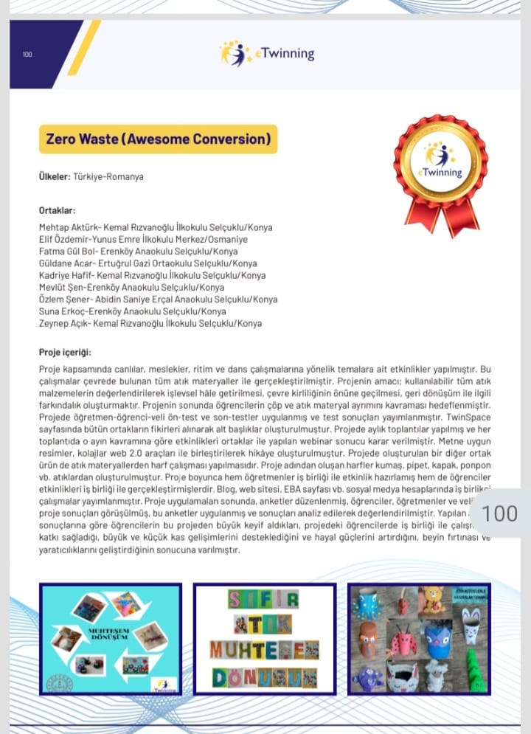

PHOTOS FROM OUR SAMPLE ACTIVITIES

In the Reggio Emilia approach, children are provided with concrete experiences and opportunities to make new discoveries. Children go through the stages of research, production and testing their hypotheses respectively. In this area, they have the opportunity to express themselves in many symbolic ways such as drawing, sculpture, dramatic play. This view, which Reggio educators call "the child's facial language", is the primary way of transformiN of children's concrete experiences into symbolic expressions.

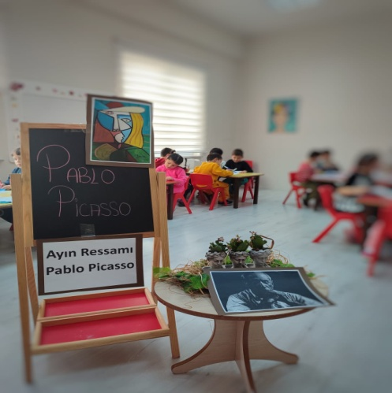 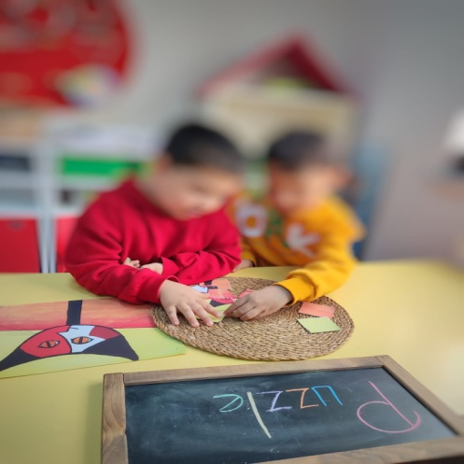

Thomas Edison is an American inventor and businessman who greatly influenced 20th century life with his inventions. He developed devices in many fields such as electrical energy production, mass communication, sound recording and filmmaking.

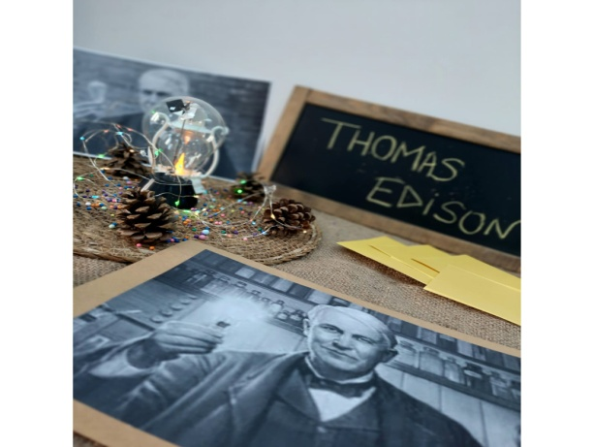

Children are inquisitive, productive and test their hypotheses. They can use many different symbolic tools to express themselves. For example, painting, sculpture, music, shadow play, dramatic play. In the Reggio approach, this is called the "Face Language of the Child".

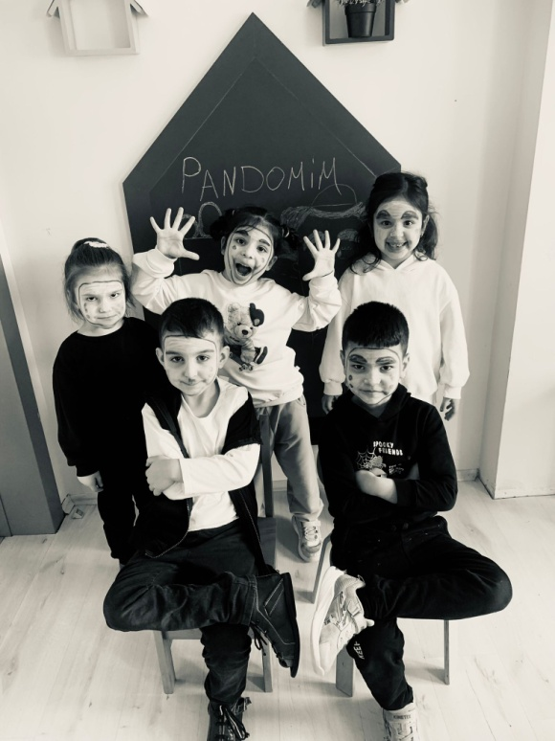 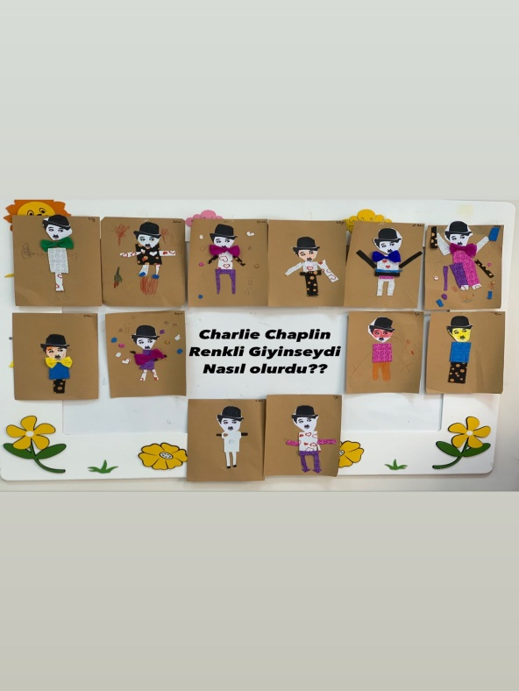

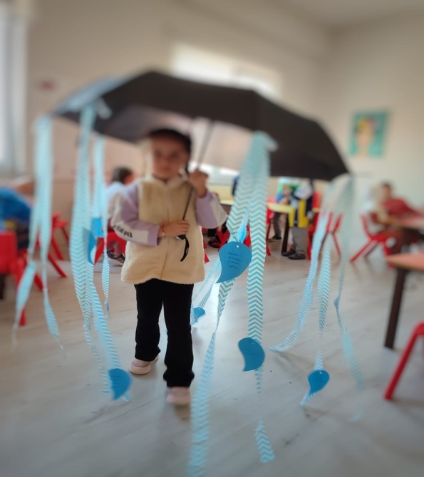 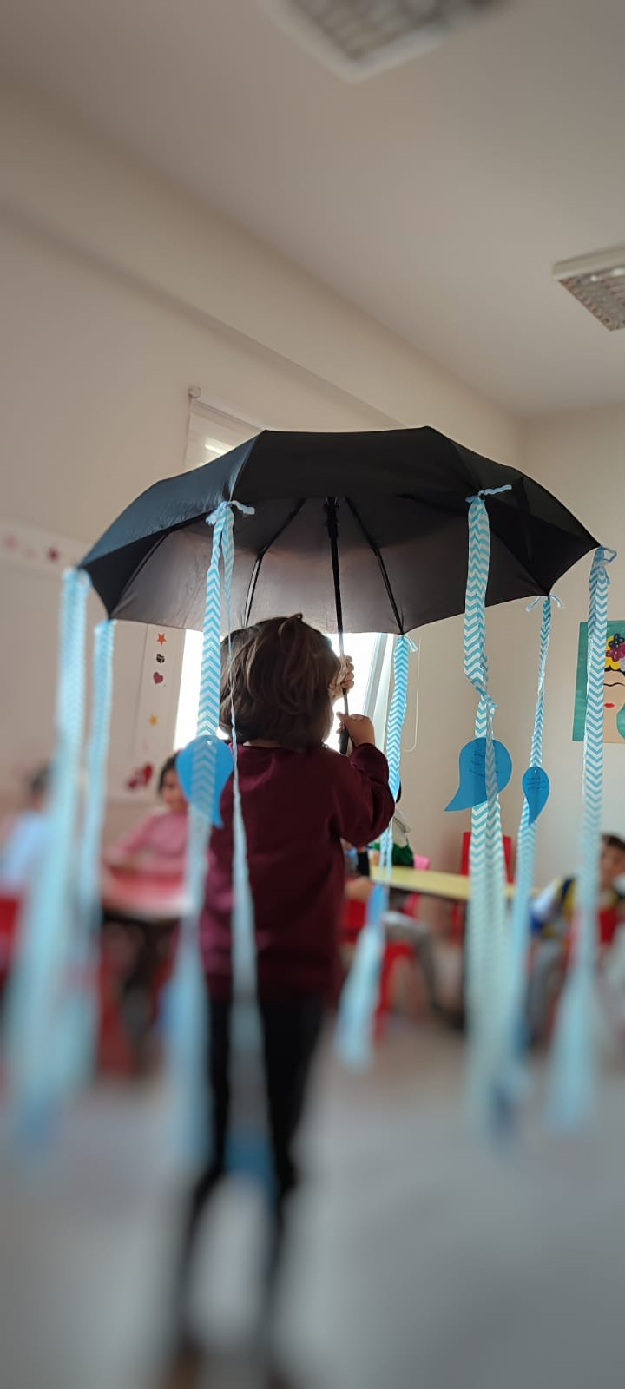

The child is the one who swings to swing, who runs just because he can run, who lives to live. And the secret of happiness is in the child. Because the child is not waiting for happiness, but creating and living it. Reggio children do not need an object or flashy areas to have fun, as we said, the secret of happiness is in the child.

We love the earth, green, trees, animals...

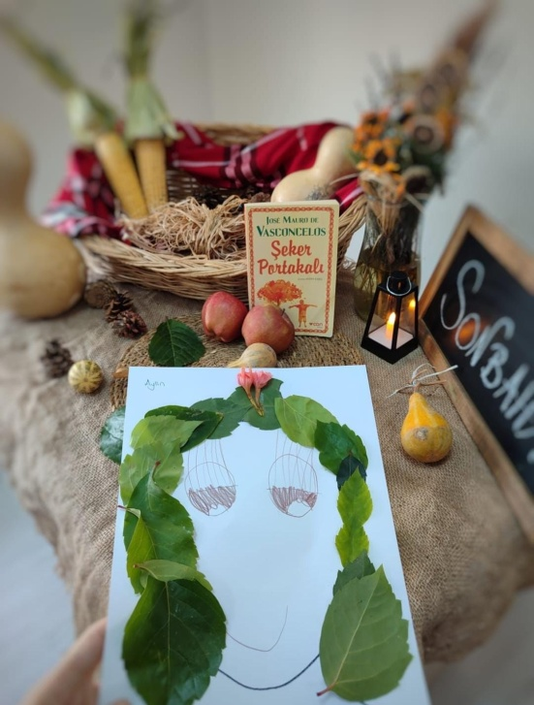 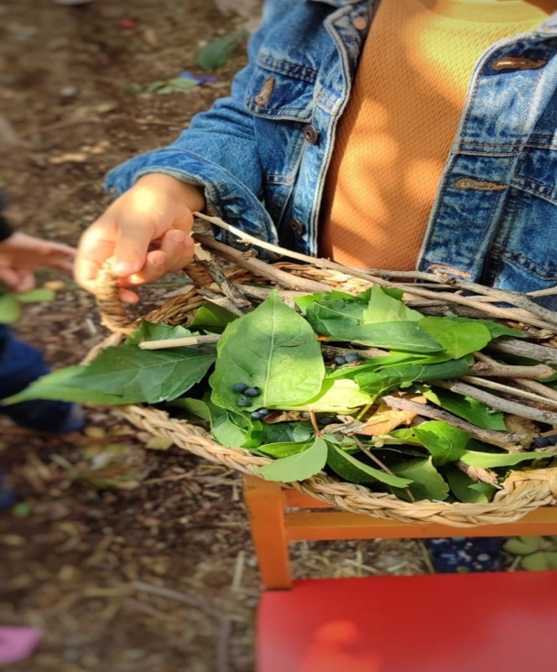

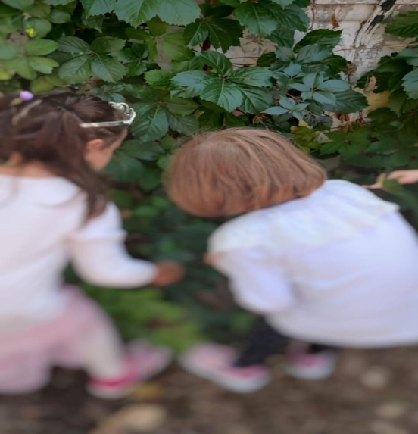 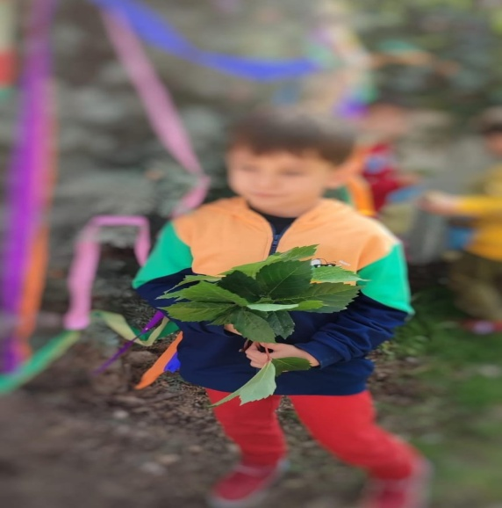

"In Reggio education, every morning starts with a "circle time". Circle time is a special time period where we chat about certain themes such as seeds and recycling and ask questions. As you know, our project this month is 'RECYCLING'. We have compiled the questions and answers we asked the children for you. We are ending our project but we continue the responsibilities we have taken. We now know that wastes such as paper, glass and plastic are not rubbish but recycling materials.

The Reggio Emilia approach emphasises that there are many ways for the child to express himself in the appropriate learning environment with Malaguzzi's statement "100 languages of the child", we collected branches, leaves, flowers, cones from nature and created our self-picture.

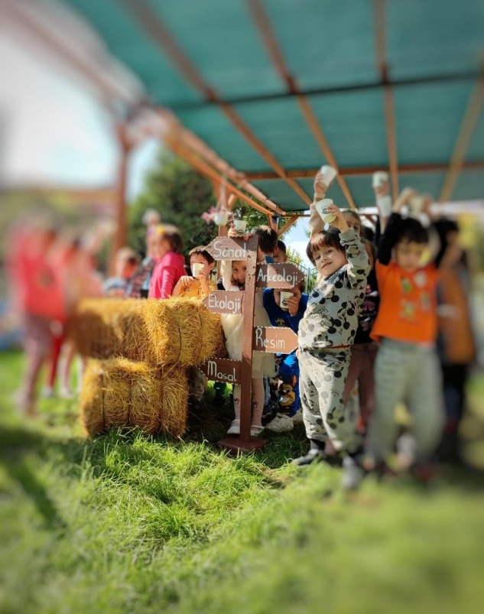 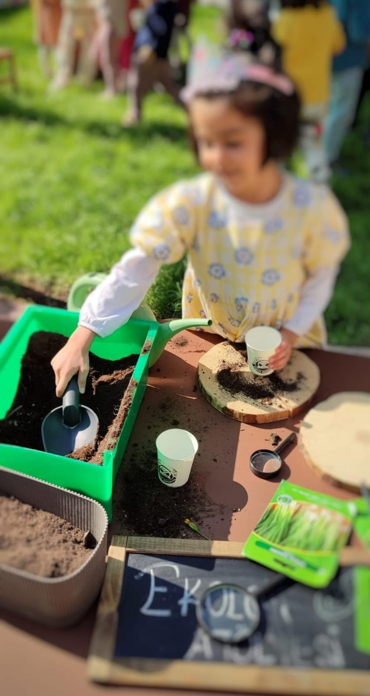

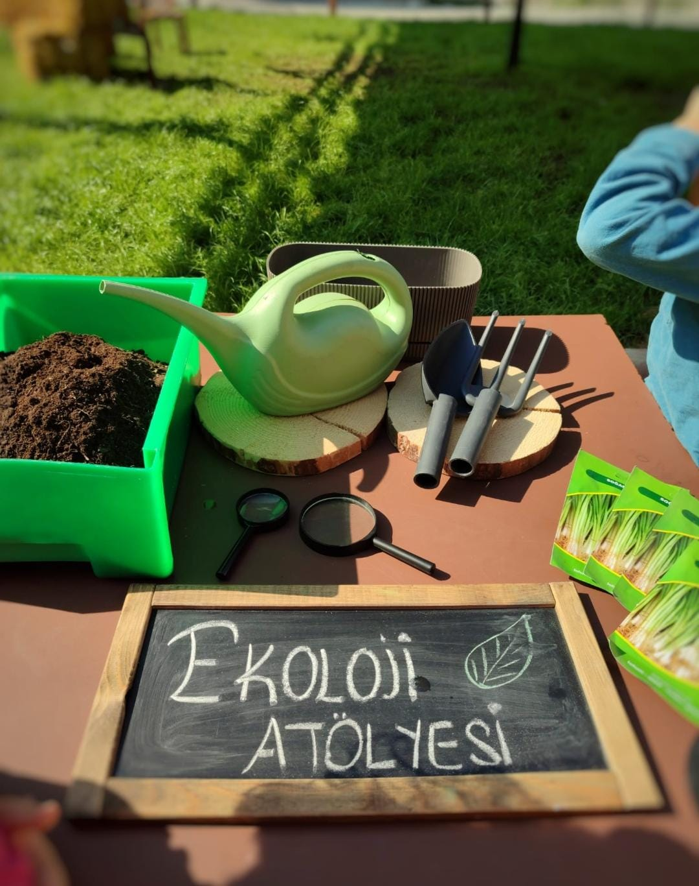 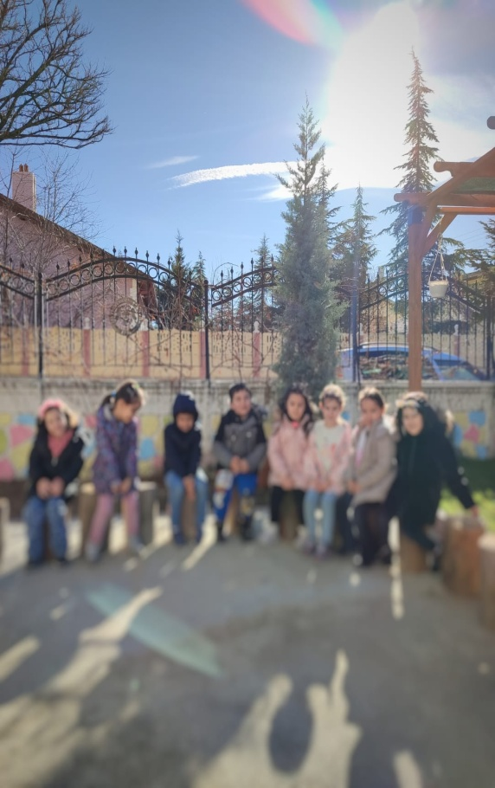

LIFE CYCLE OF THE BUTTERFLY

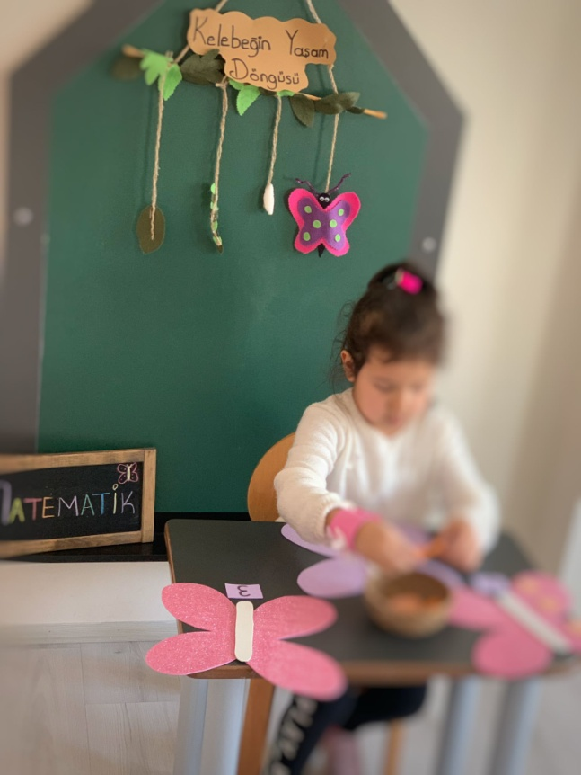

CHILD-CENTRED SELF-CARE SKILLS

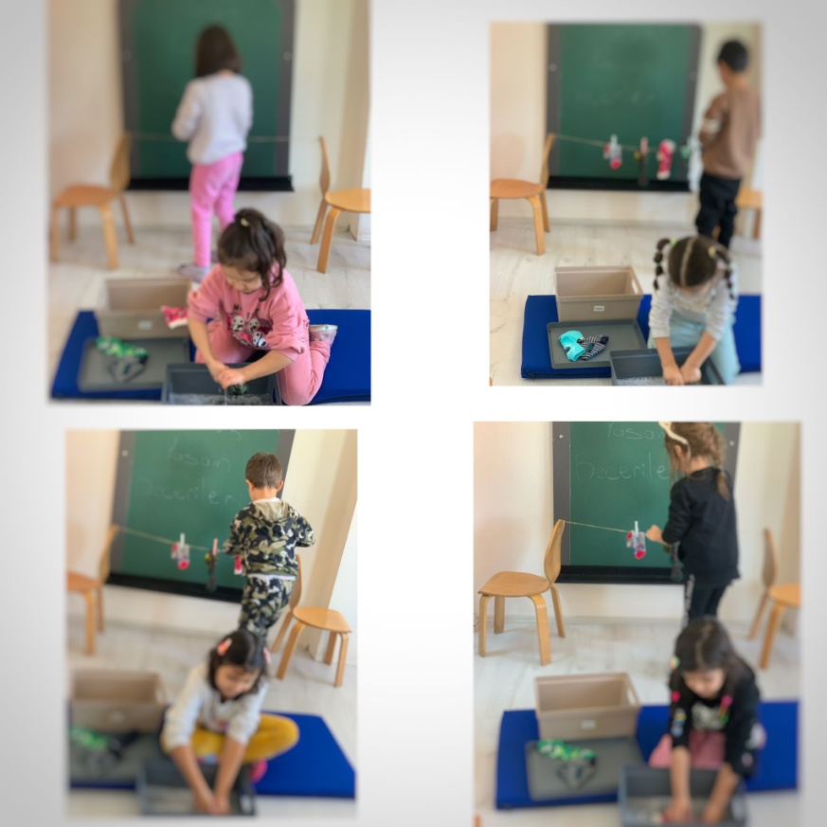

HOW FISH SWIM

Description: Since fish have air in their swim bladders, they can easily swim in water.

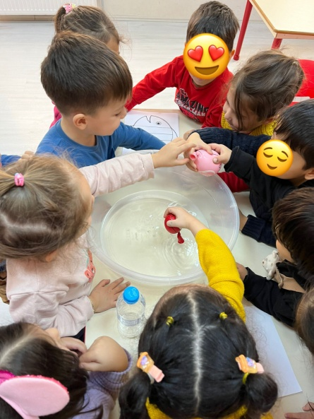

WE PREPARE WINTER TEA (HOW CAN WE PROTECT OUR BODY TO AVOID GETTING SICK?

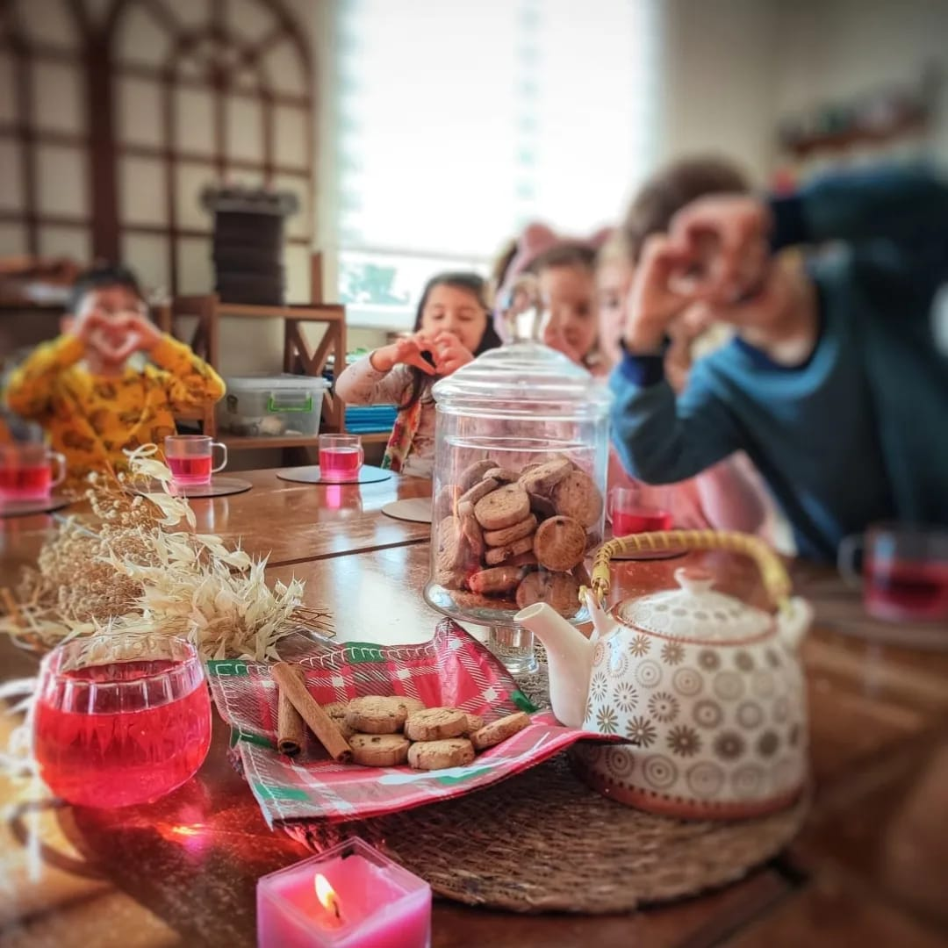

FAMILY PARTICIPATION ACTIVITY VOLCANO EXPERIMENT

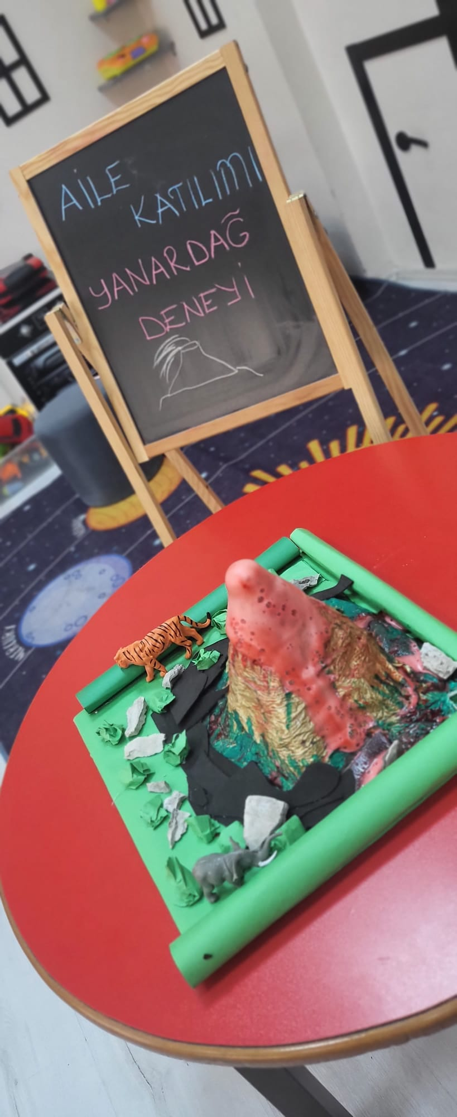

GAME MOVEMENT

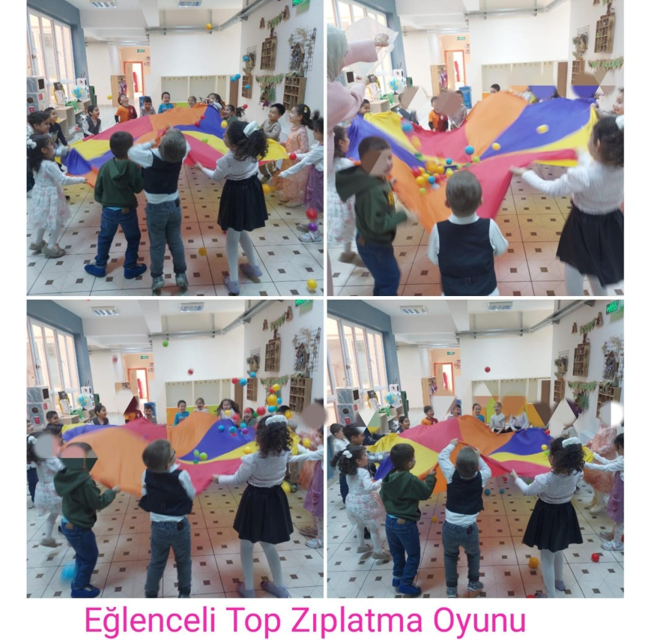

CLIMBING PHYSICAL ACTIVITIES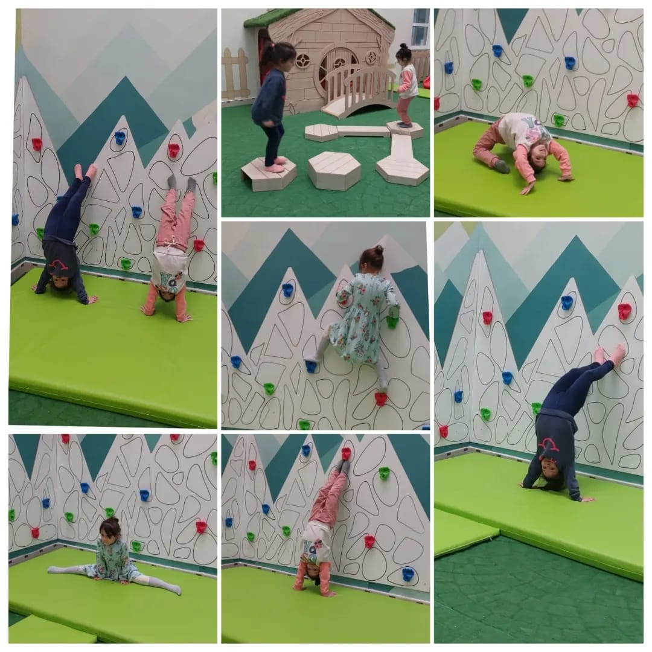

THE PRESENCE OF LIGHT

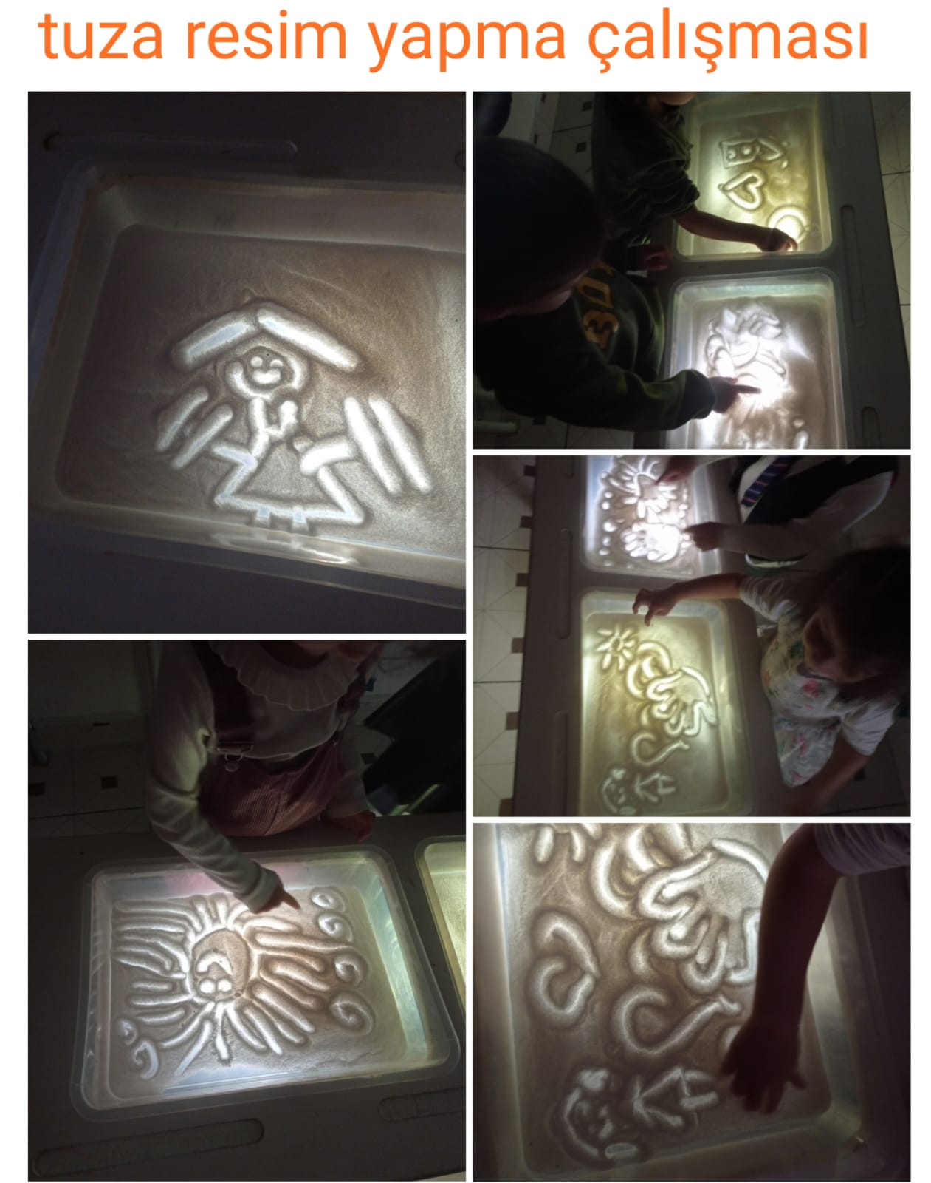

OTHER ACTİVİTİES

WAFFLE

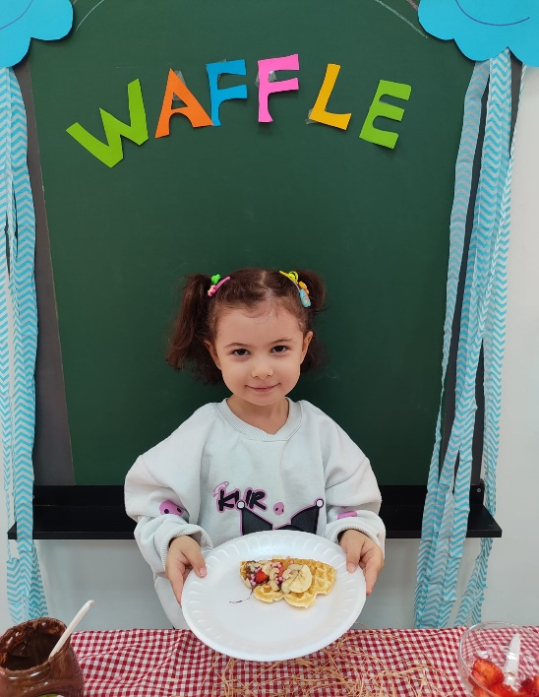 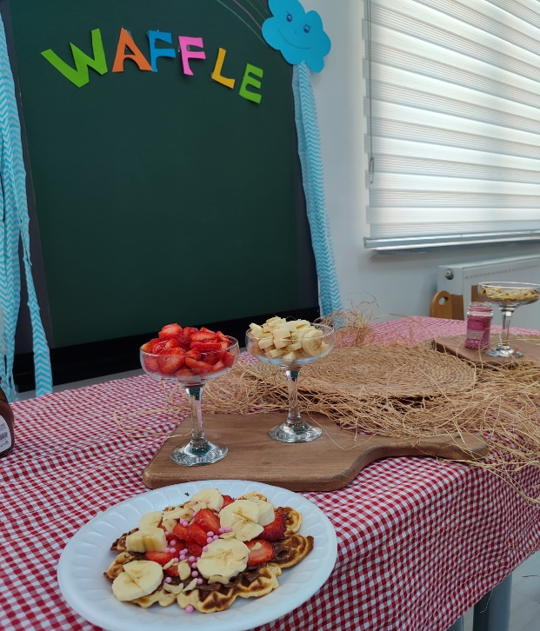

TİME İN NATURE

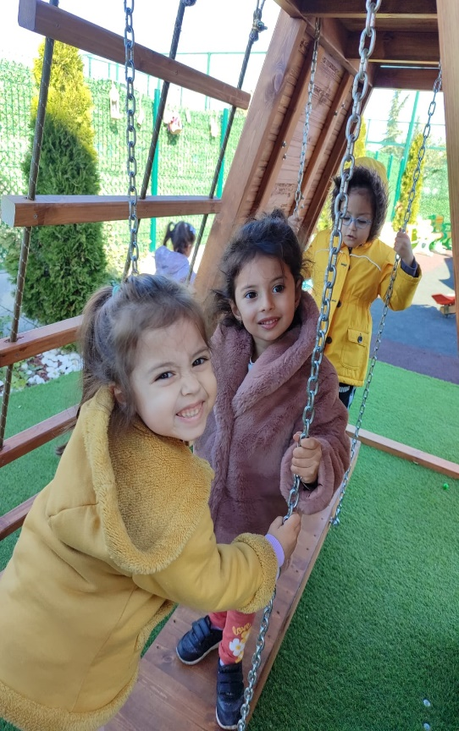 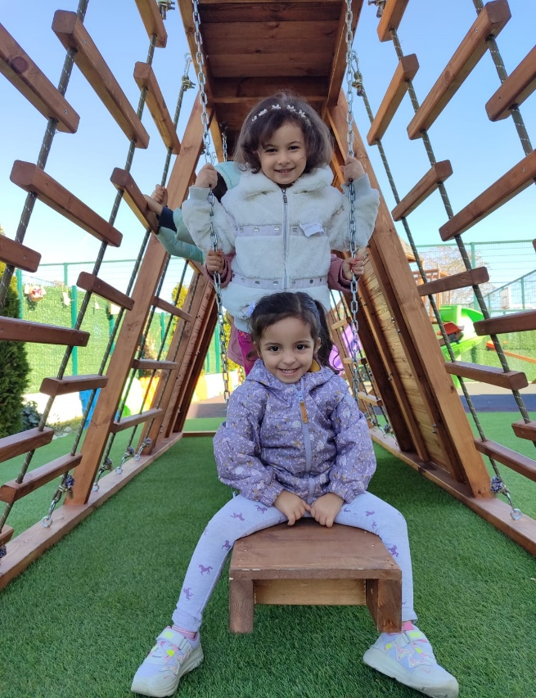

SEWİNG WORKSHOP

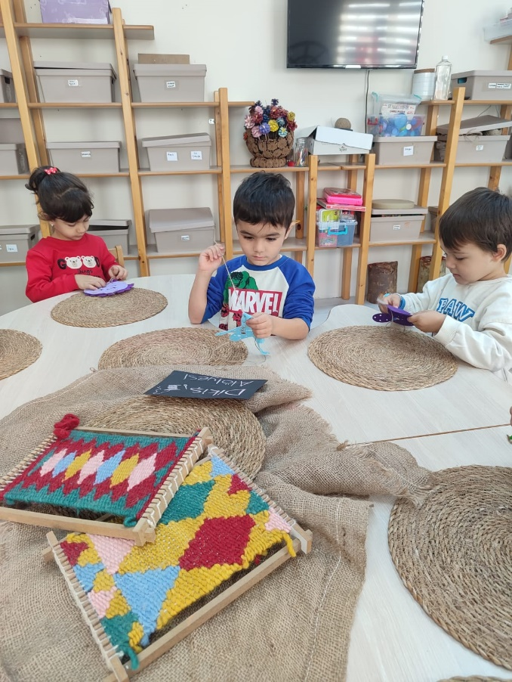 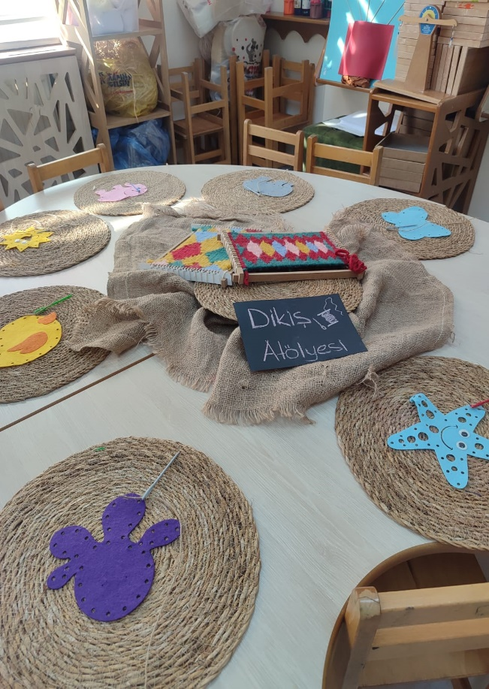

PABLO PİCASS

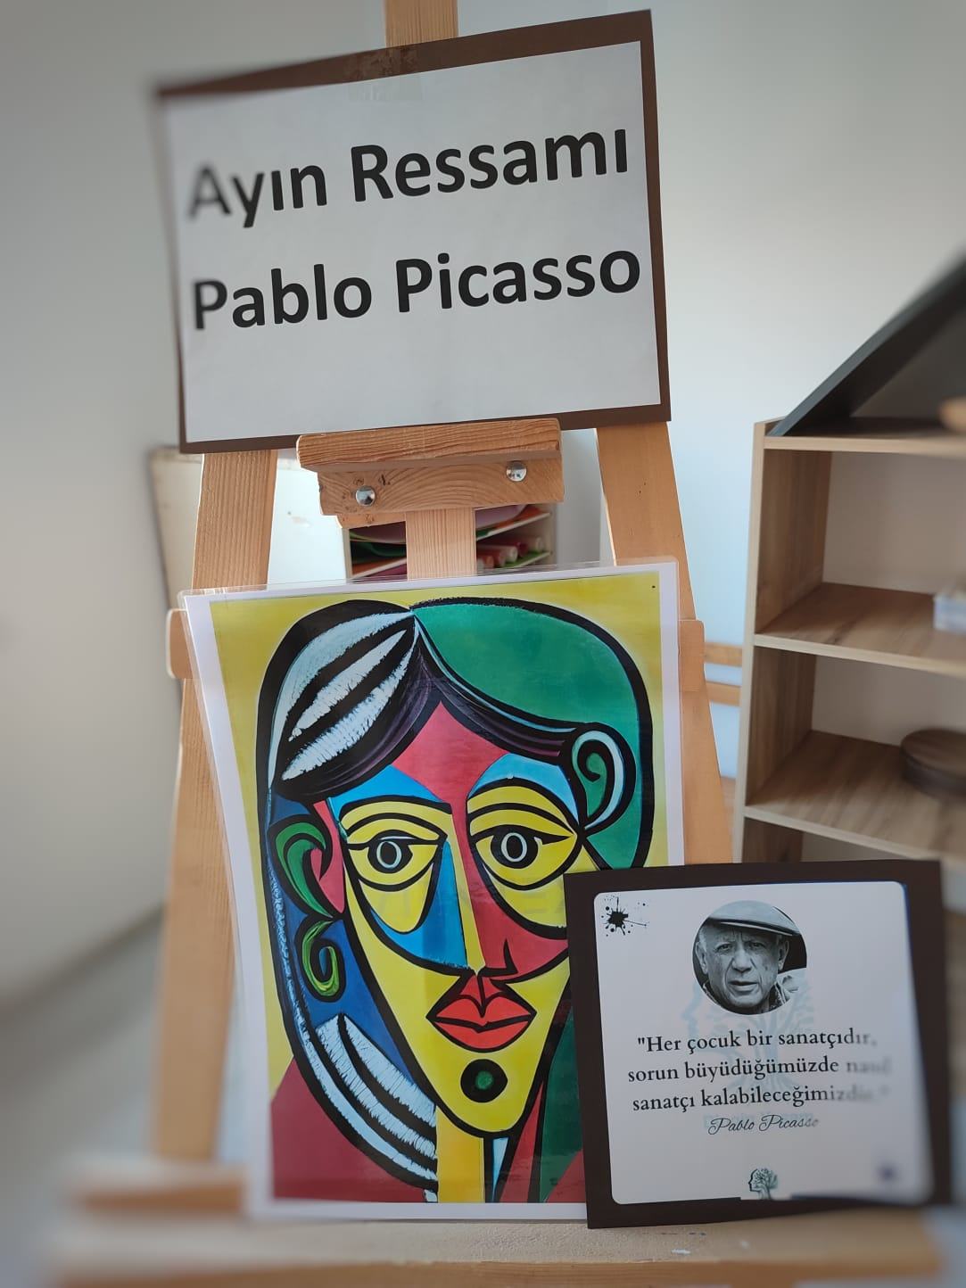 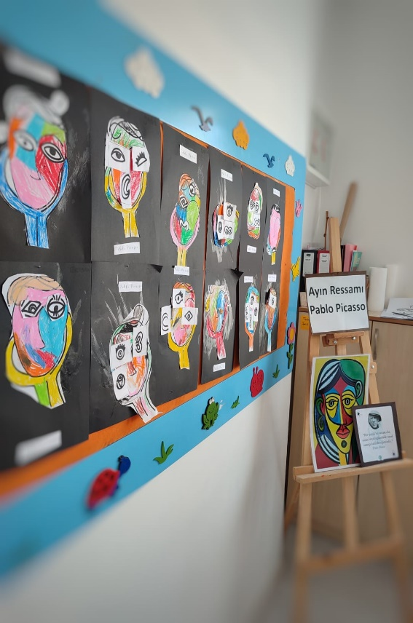

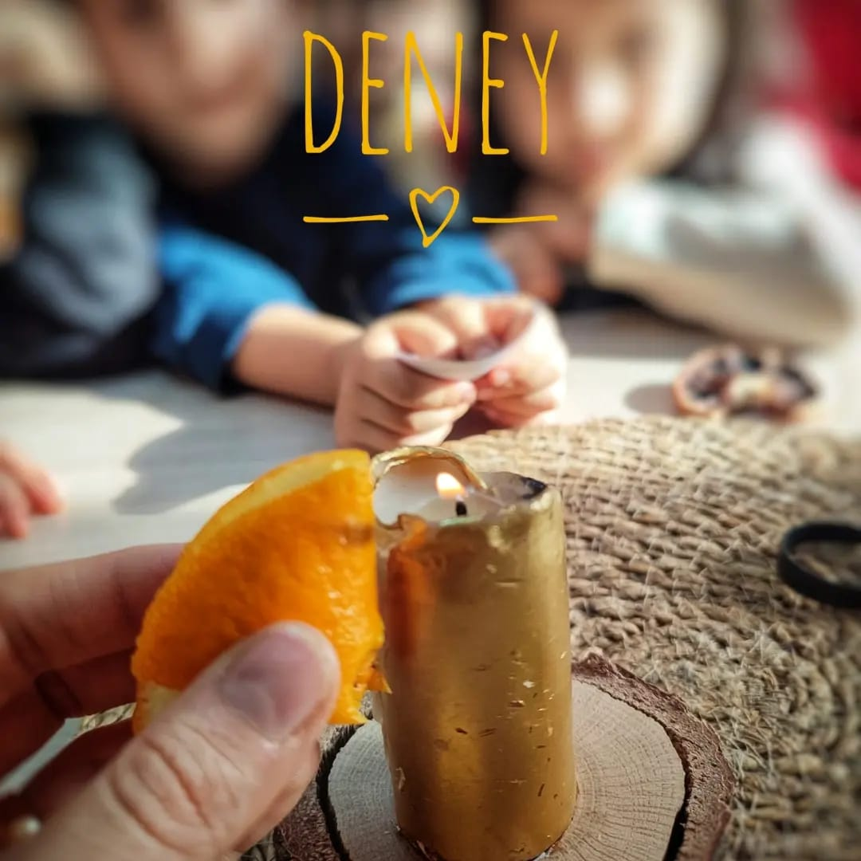

PHOTOS FROM OUR SCHOOL'S SENSORY INTEGRATION ACTIVITY EXAMPLES

